World War II, Civil Defense Plan

Sixty five years ago I would have either been locked up or possibly shot for revealing what I am about to reveal here. This arrived to us in an envelope still marked as SECRET. I think both the world and Takeley have changed sufficiently that what follows is now out of date.

Quite simple this is the Takeley Civil Defense plan from, 1943. Whilst some of it does make me smile because we have been preconditioned by Dad’s Army to find the ringing of Church bells and blowing of whistles in the face of an invading army slightly quaint, other aspects such of the provision of emergency mortuary and burial space does make you realise that this was for real.

Steve Hazon
Chairman, Takeley Local History Society
April 2009

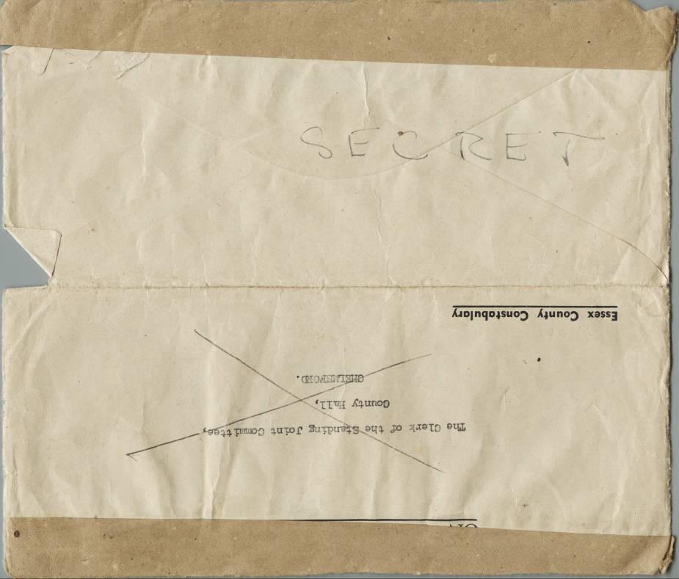
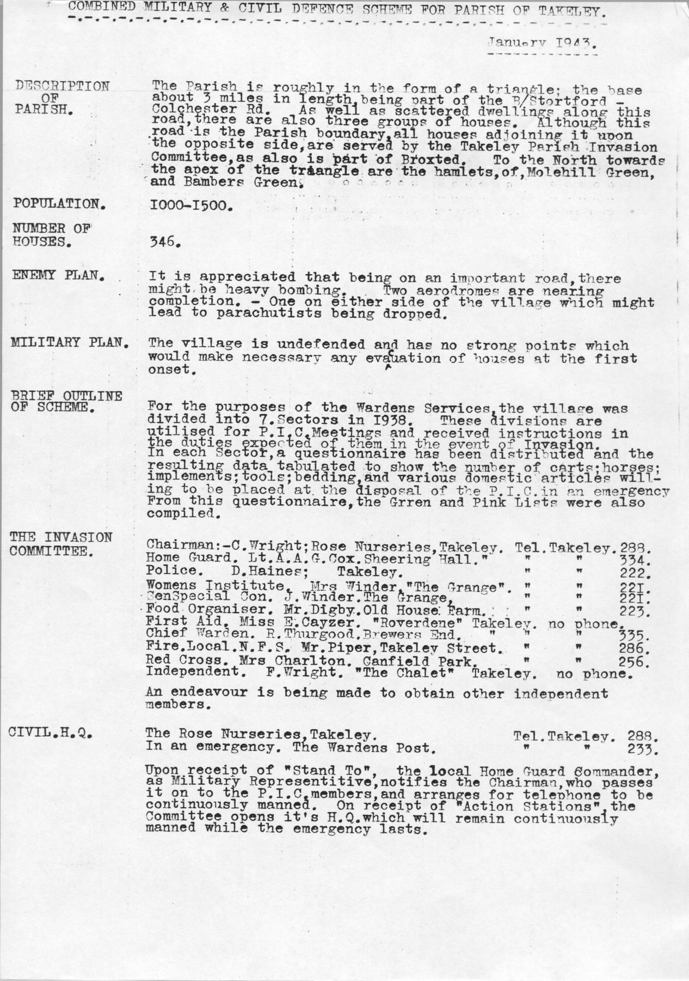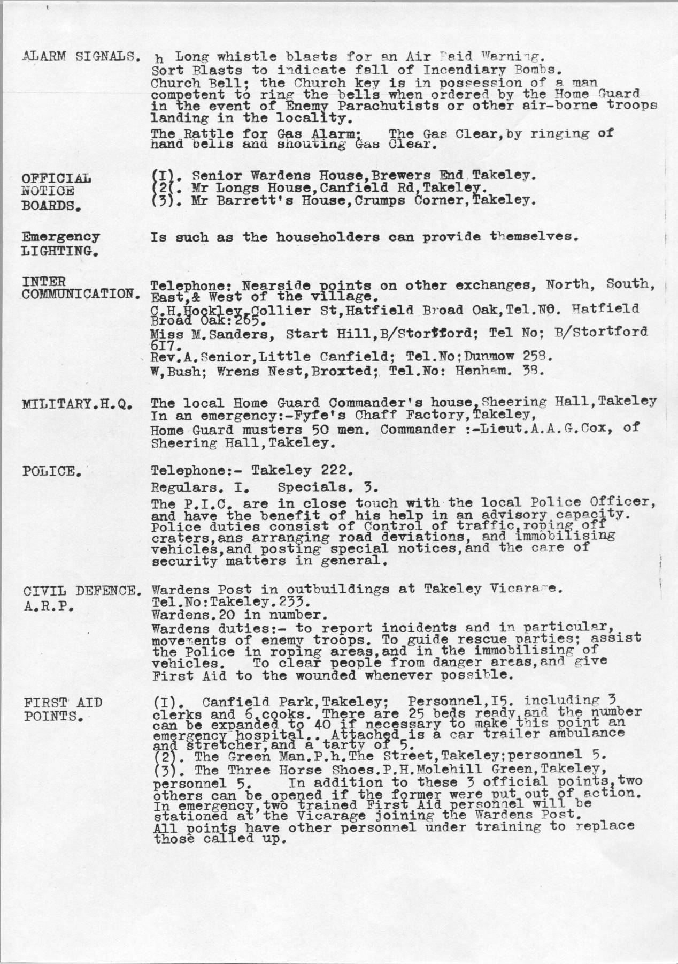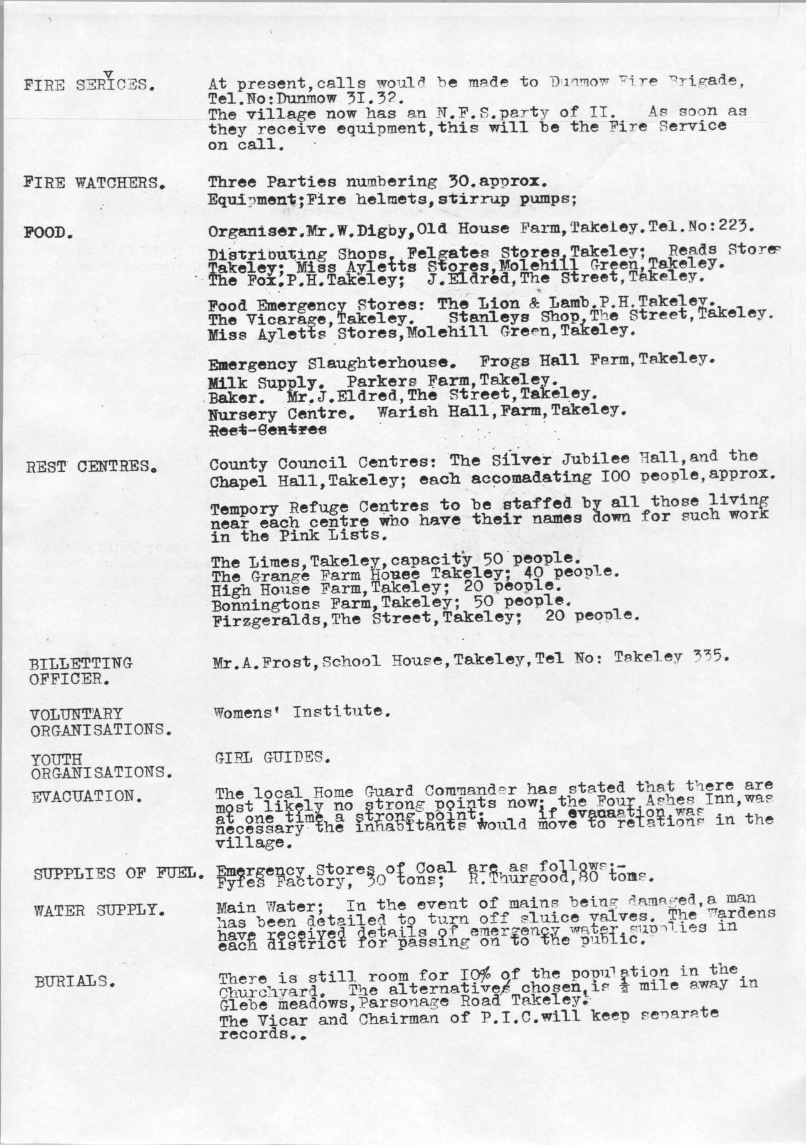
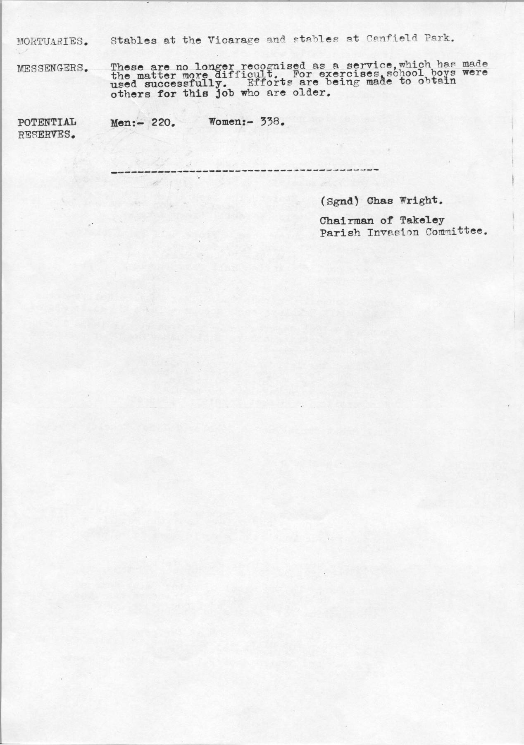
To further set the scene, paper, like everything else, was in short supply and so this was typed on the back of pre-used paper, in this case a baby’s gas mask instructions from 1939.

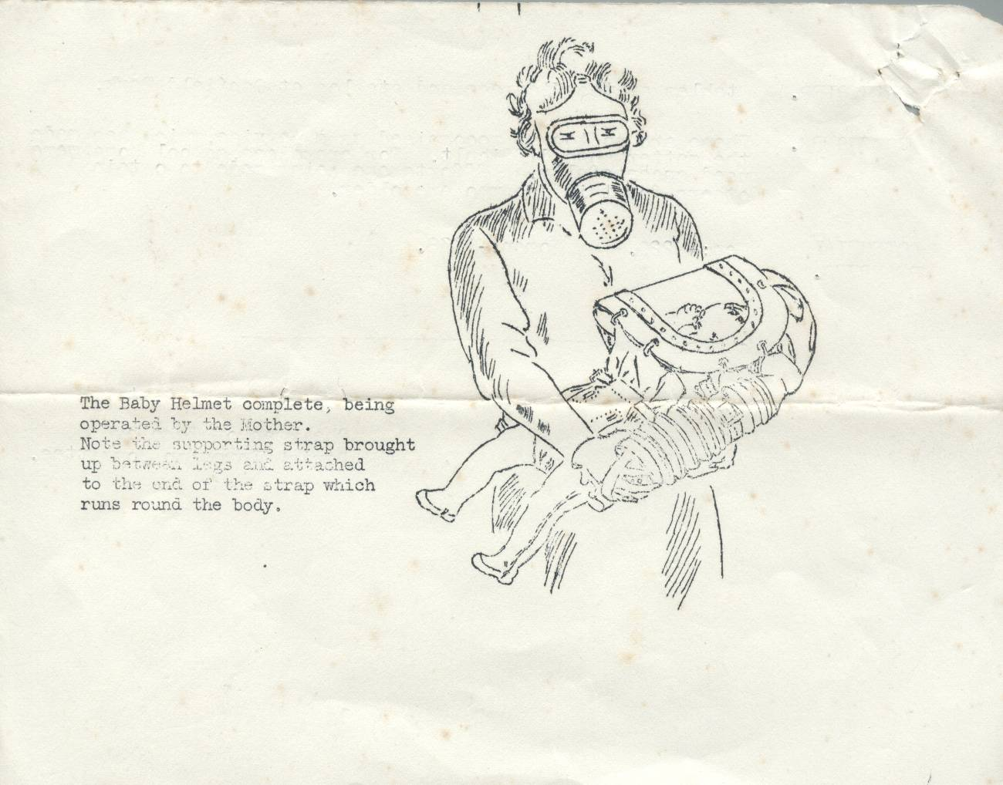
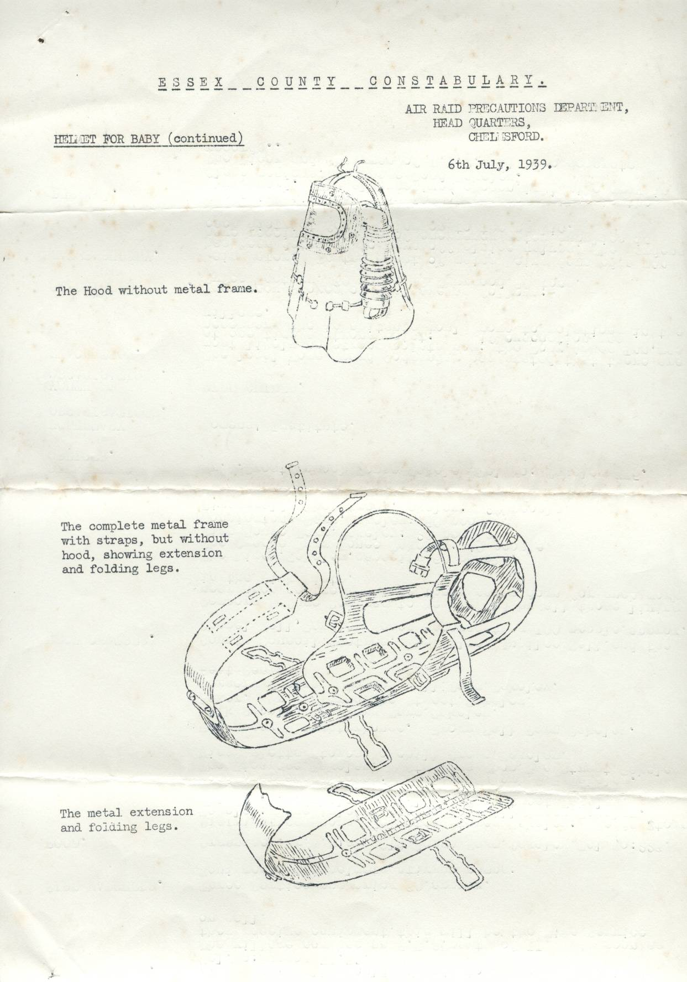
And finally on the rear of the other two pages patrol areas for the ARP and an equipment list for Fast Cars.

